Assignment 3: MongoDB

Use the following link to execute your commands in a MongoDB online terminal. Please note, this online terminal does not store any data. You can make the screen full size. I suggest you type your commands in a text editor and then copy paste in case you lose your session. https://docs.mongodb.com/manual/tutorial/query-documents/

If you prefer to install MongoDB follow the instructions in link below for the community edition of MongoDB
https://docs.mongodb.com/manual/installation/

For each question you must provide a screen shot which CLEARLY shows the command and the results.

Question 1:
- Create a collection called Employees

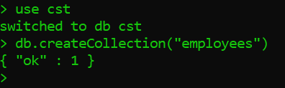

- Insert the following documents in the collection Employees. You will have three fields, employeeid, name and title and they contain the values listed below

Employeeid | Name | Title
1 | Jones | Manager IT
2 | Smith | Payroll Clerk
3 | Green | Supervisor

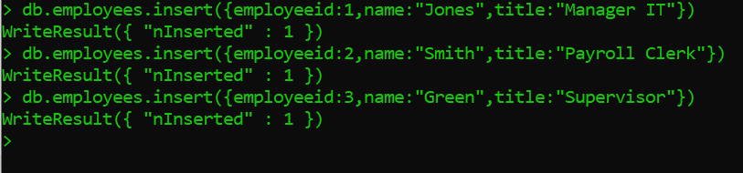

Question 2:
- Print the above inserted documents in json format

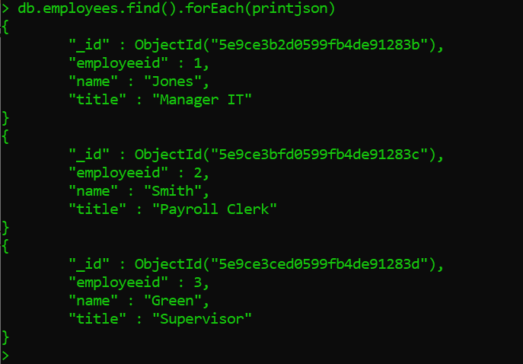

Question 3:
- Create a variable called myemployeevar to insert the following documents

Employeeid | Name | Title
4 | Lawson | Clerk
5 | Neilson | Manger Accounting
6 | Michaels | Supervisor

- Insert the documents above in the collection using the variable myemployeevar

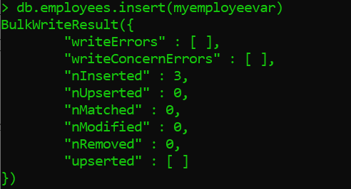

- Show that all documents have been included

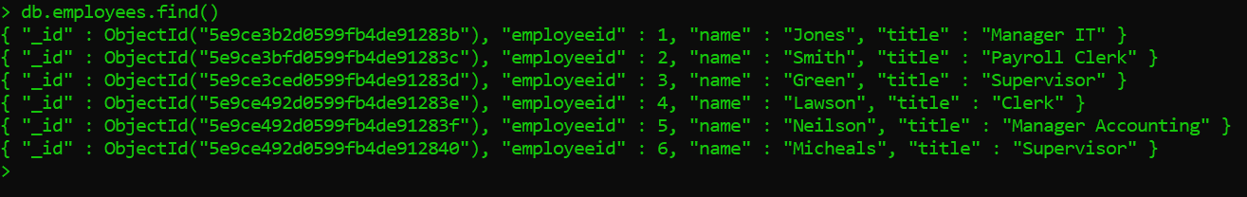

Question 4:
- Update the title for Lawson, employeeid 4 to “Senior Clerk”

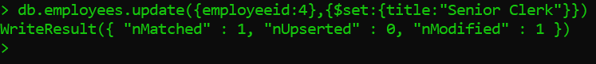

- Show that the document has been updated

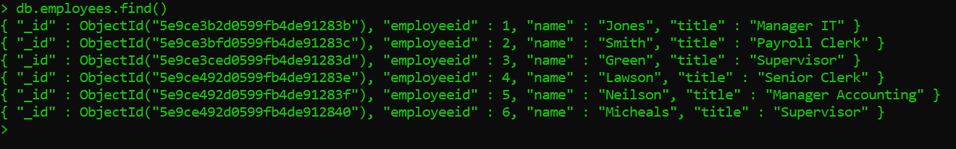

Question 5:
- Delete the document for Michaels employeeid 6

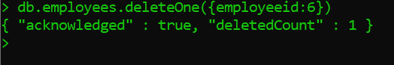

- Show that the document has been updated

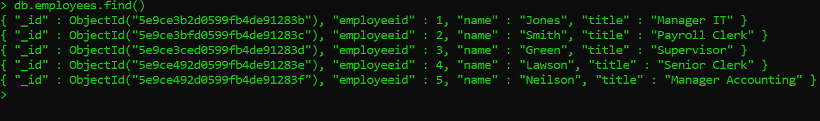

Question 6:
- Display the entire list in descending order

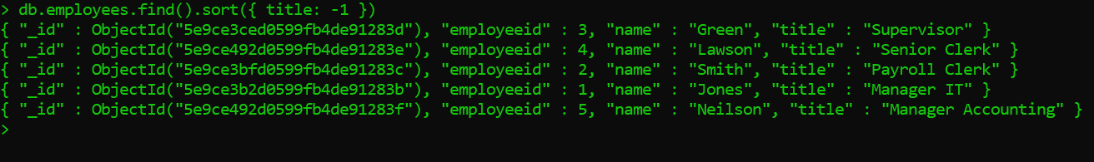

- Display the entire list in ascending order

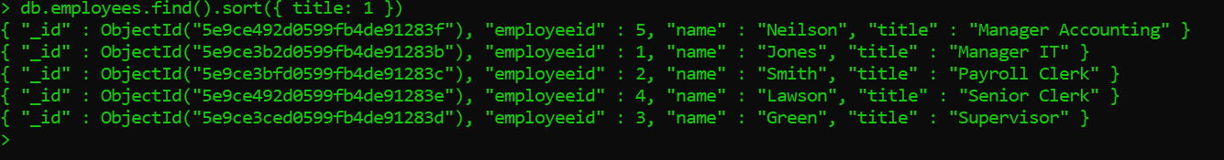

Question 7:
- Create at text index on title

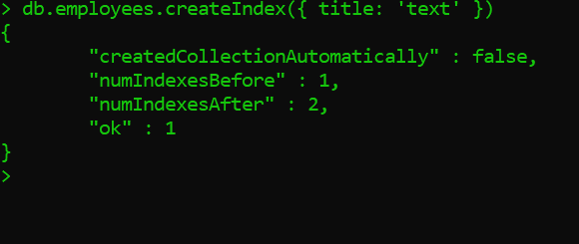

- Search the title field for the word “Clerk”

- Search the title field for the word “Manager”

